**RAD MODEL**

RAD is a linear sequential software development process model that emphasizes a concise development cycle using an element based construction approach. The RAD (Rapid Application Development) model is based on prototyping and iterative development with no specific planning involved. The process of writing the software itself involves the planning required for developing the product. Rapid application development is a software development methodology that uses minimal planning in favor of rapid prototyping. A prototype is a working model that is functionally equivalent to a component of the product. If the requirements are well understood and described, and the project scope is a constraint, the RAD process enables a development team to create a fully functional system within a concise time period. RAD projects follow iterative and incremental model and have small teams comprising of developers, domain experts, customer representatives and other IT resources working progressively on their component or prototype.

* Gathering requirements using workshops or focus groups.
* The re-use of software components.
* Less formality in reviews and other team communication.

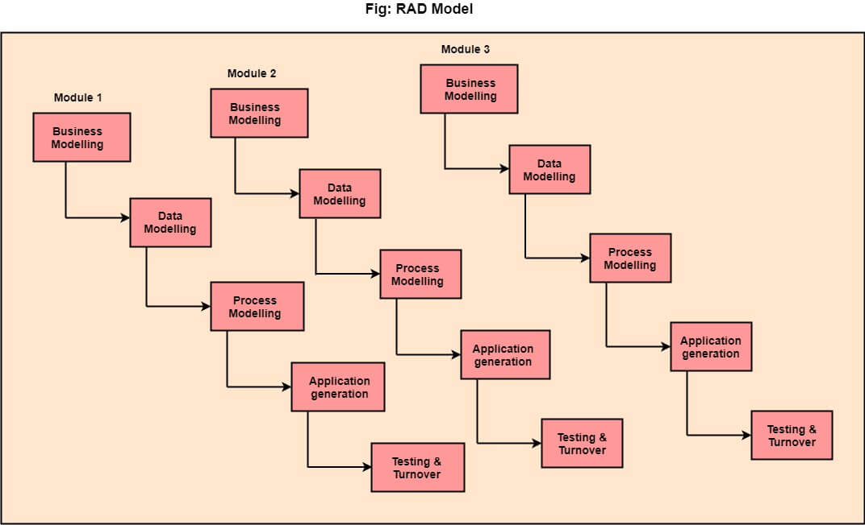

The various phases of RAD are:

**1. Business Modelling. :** The business model for the product under development is designed in terms of flow of information and the distribution of information between various business channels.

**2. Data Modelling. :** The information gathered in the Business Modelling phase is reviewed and analysed to form sets of data objects vital for the business.

**3. Process Modelling. :** The data object sets defined in the Data Modelling phase are converted to establish the business information flow needed to achieve specific business objectives as per the business model.

**4. Application Generation. :** The actual system is built and coding is done by using automation tools to convert process and data models into actual prototypes.

**5. Testing & Turnover. :** The overall testing time is reduced in the RAD model as the prototypes are independently tested during every iteration.

## Advantages of RAD Model:

* This model is flexible for change.
* In this model, changes are adoptable.
* Each phase in RAD brings highest priority functionality to the customer.
* It reduced development time.
* It increases the reusability of features.

## Disadvantages of RAD Model:

* It required highly skilled designers.
* All application is not compatible with RAD.
* For smaller projects, we cannot use the RAD model.
* On the high technical risk, it's not suitable.
* Required user involvement.